DAY3 LISTS

1. Write a Python program to sum all the items in a list.

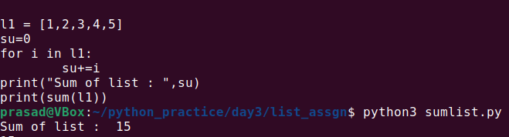

2. Write a Python program to multiply all the items in a list.

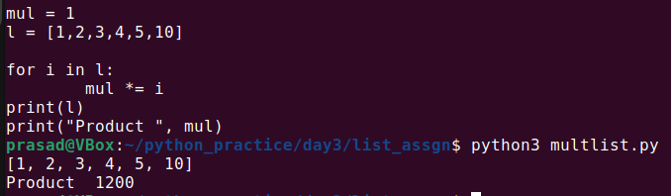

3. Write a Python program to get the largest number from a list.

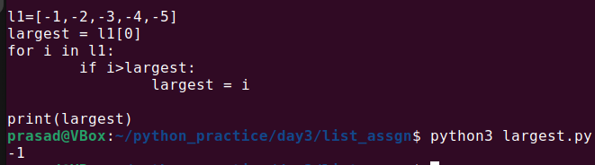

4. Write a Python program to get the smallest number from a list.

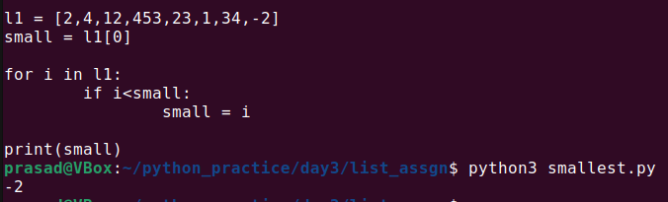

5. Write a Python program to count the number of strings from a given list of strings. Condition is, the string length is 2 or more and the first and last characters are the same.

Sample List : ['abc', 'xyz', 'aba', '1221']

Expected Result : 2

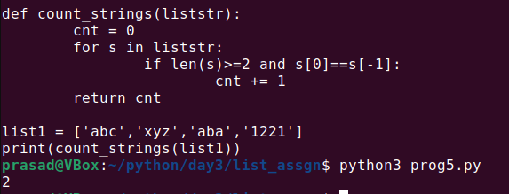

6. Write a Python program to get a list, sorted in increasing order by the last element in each tuple from a given list of non-empty tuples.

Sample List : [(2, 5), (1, 2), (4, 4), (2, 3), (2, 1)]

Expected Result : [(2, 1), (1, 2), (2, 3), (4, 4), (2, 5)]

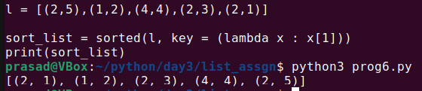

7. Write a Python program to remove duplicates from a list. Use another list to store unique values.

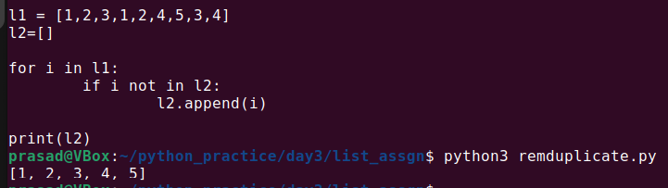

8. Write a Python program to check if a list is empty or not.

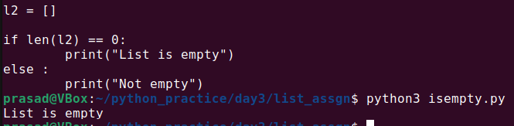

9. Write a Python program to clone or copy a list.

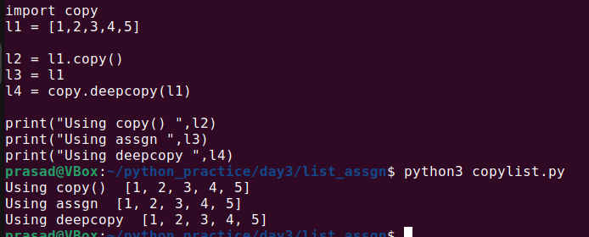

10. Write a Python program to find the list of words that are longer than n from a given list of words.

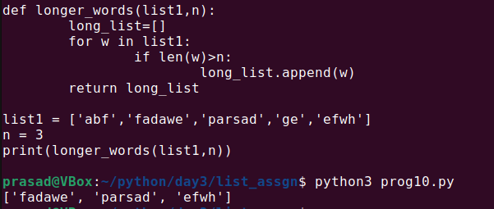

11. Write a Python program which has two lists and returns True if they have at least one common member.

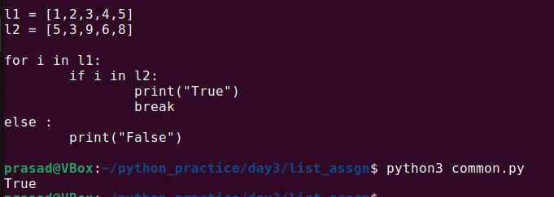

12. Write a Python program to print a specified list after removing the 0th, 4th and 5th elements.

Sample List : ['Red', 'Green', 'White', 'Black', 'Pink', 'Yellow']

Expected Output : ['Green', 'White', 'Black']

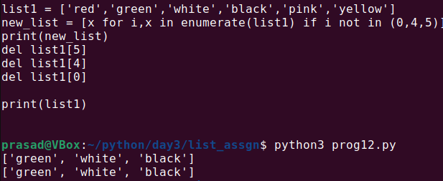

13. Write a Python program to generate a 3*4*6 3D array whose each element is *.

14. Write a Python program to print the numbers of a given list after removing even numbers from it.

Ex. l1=[10,25,45,78,90,103,455]

o/p :: [25,45,103,455]

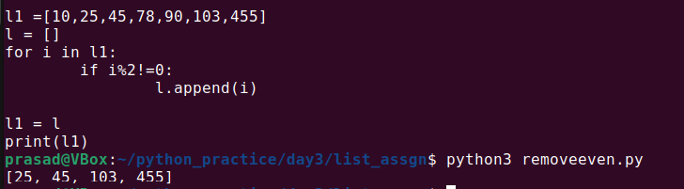

15. Write a Python program to shuffle and print a specified list.

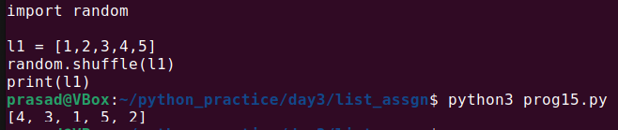

16. Write a Python program to generate and print a list of the first and last 5 elements where the values are square numbers between 1 and 30 (both included).

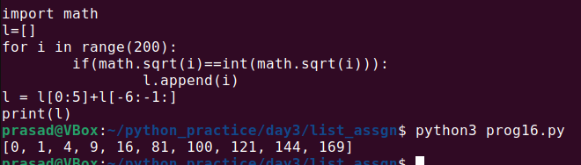

17. Write a Python program to check if each number is prime in a given list of numbers. Return True if all numbers are prime otherwise False.

Sample Data:

([0, 3, 4, 7, 9]) -> False

([3, 5, 7, 13]) -> True

([1, 5, 3]) -> False

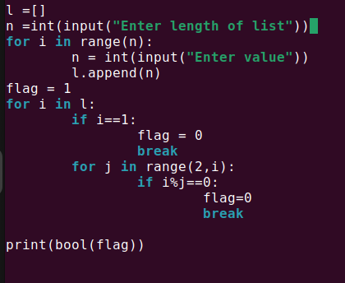

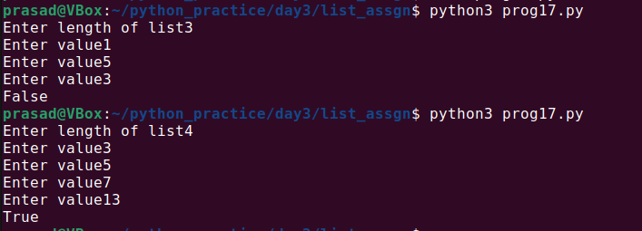

18. Write a Python program to generate all permutations of a list in Python.

[Hint use library iteratortools]

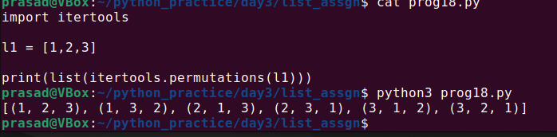

19. Write a Python program to calculate the difference between the two lists.

ex.

l1=[1,4,7,8]

l2=[2,5,7,23]

ans => total difference is 17

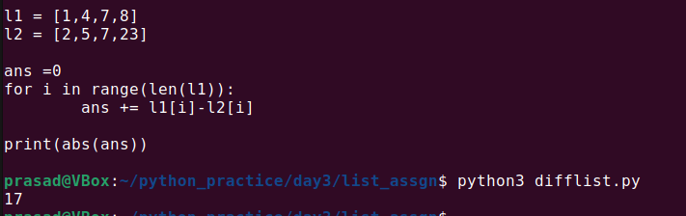

20. Write a Python program to access element at given index of a list.

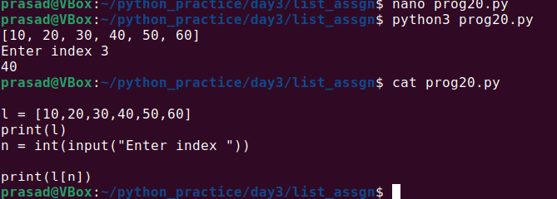

21. Write a Python program to convert a list of characters into a string.

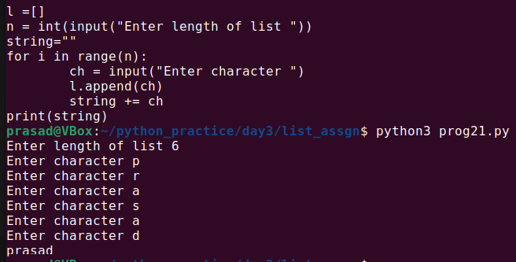

22. Write a Python program to find the index of an item in a specified list.

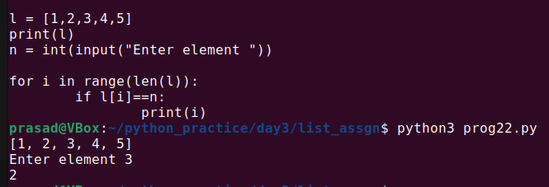

23. Write a Python program to flatten a simple list.

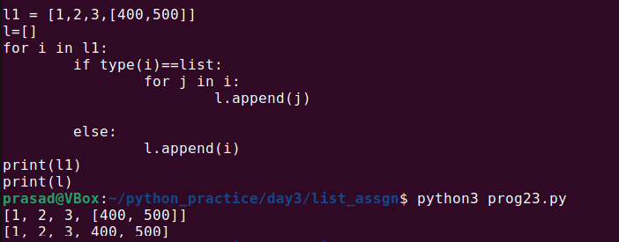

24. Write a Python program to append all elements from a list to the second list.

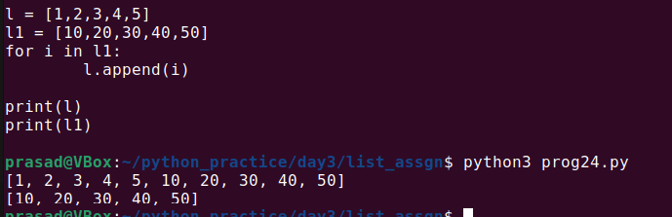

25. Write a Python program to select an item randomly from a list. ( use randint function from random library)

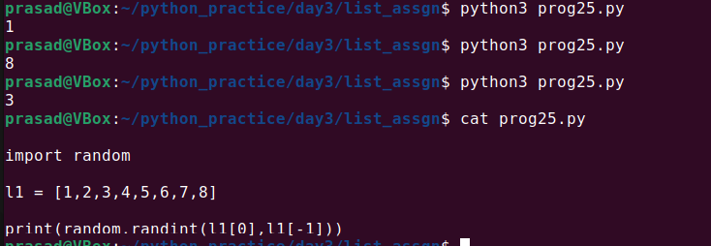

26. Write a Python program to check whether two lists are circularly identical.

Ex.

l1=[1,2,3,4]

l2=[2,3,4,1]

l3=[4,1,2,3]

l4=[3,4,1,2]

all l1, l2, l3 and l4 are circularly same

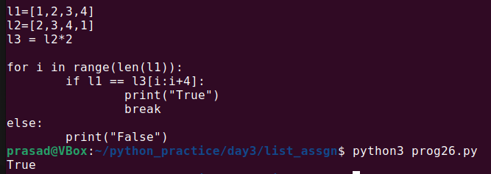

27. Write a Python program to find the second smallest number in a list.

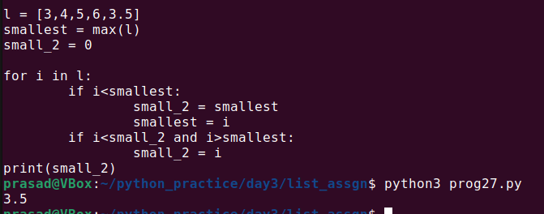

28. Write a Python program to find the second largest number in a list.

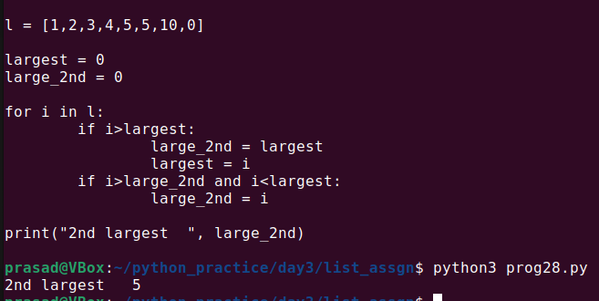

29. Write a Python program to get unique values from a list.

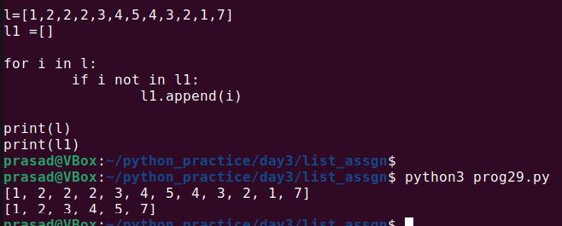

30. Write a Python program to get the frequency of every element in a list

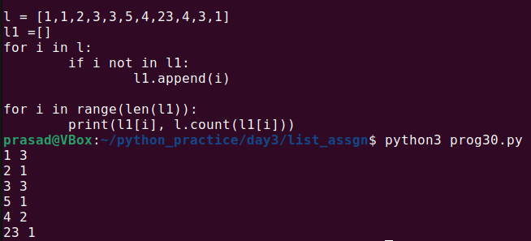

31. Write a Python program to count the number of elements in a list within a specified slice ( range) of start and end index.

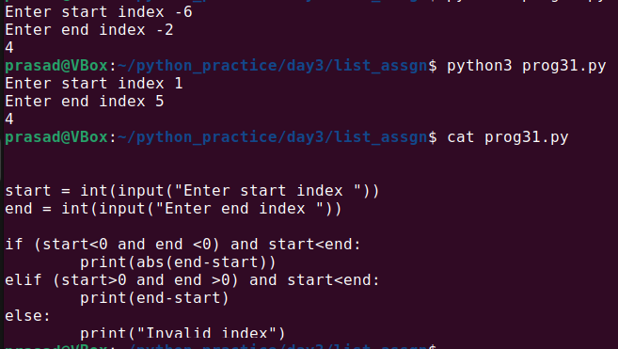

32. Write a Python program to check whether a list contains a sublist. ( all elements from one list are present in other list)

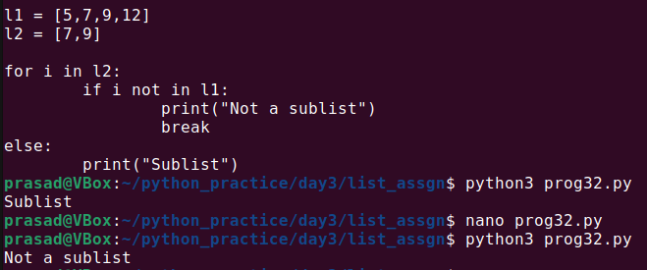

**33. Write a Python program to generate all sublists of a list.

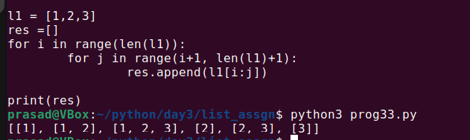

**34. Write a Python program that uses the Sieve of Eratosthenes method to compute prime numbers up to a specified number.

Note: In mathematics, the sieve of Eratosthenes, (Ancient Greek: κόσκινον Ἐρατοσθένους, kóskinon Eratosthénous) one of a number of prime number sieves, is a simple, ancient algorithm for finding all prime numbers up to any given limit.

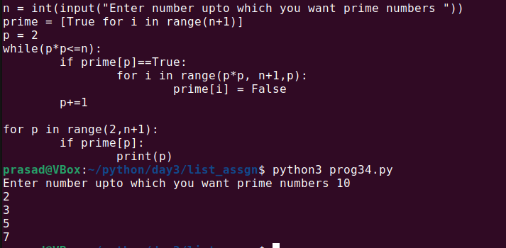

35. Write a Python program to create a list by concatenating a given list with a range from 1 to n.

Sample list : ['p', 'q']

n =5

Sample Output : ['p1', 'q1', 'p2', 'q2', 'p3', 'q3', 'p4', 'q4', 'p5', 'q5']

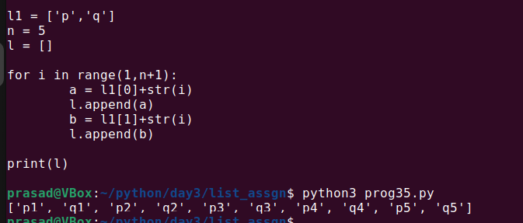

36. Write a Python program to make list of all digits from given number

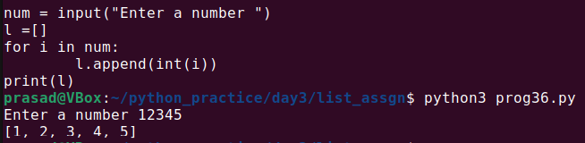

37. Write a Python program to find common items in two lists.

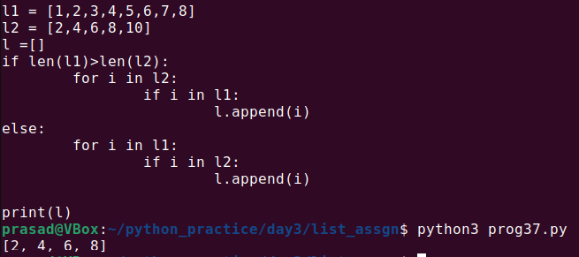

38. Write a Python program to change the position of every two consecutive elements n-th value to the (n+1)th in a list. ( swap nth and n+1 th value)

Sample list: [0,1,2,3,4,5]

Expected Output: [1, 0, 3, 2, 5, 4]

Explaination: here we have swapped

0 -1 , 2-3 , 4-5

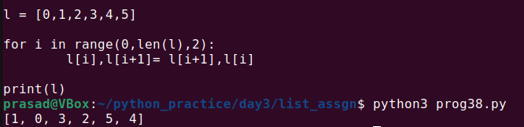

39. Write a Python program to convert a list of multiple integers into a single integer.

Sample list: [11, 33, 50]

Expected Output: 113350

ex2: l1=[8,9,0]

output : 890

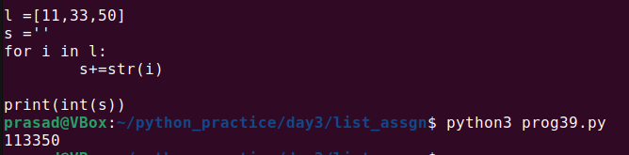

40. Write a Python program to split a list of words based on the first character of a word.

if first character is vowel then put that word in l1 else put that word in l2.

Ex.

words=['abc','xyz','op','qwe']

l1=['abc','op']

l2=['xyz','qwe']

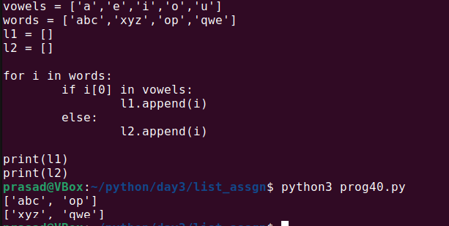

41. Write a Python program to check if given list contains another list object or not.

Ex. l1=[10,20,30]

output: no list object inside l1

l2=[10,20,[45,67]]

output: there is list object inside l2

Here [45,67] is list object inside l2

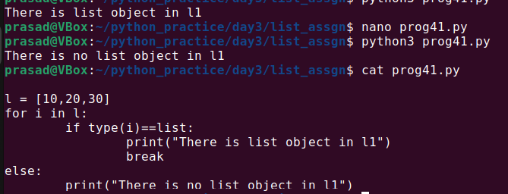

42. Write a Python program to find missing and additional values in two lists.

Sample data :

first=['b','a','c','d','e','f']

second=['d','e','f','g','h']

Missing values in second list: ['b','a','c']

Additional values in second list: ['g','h']

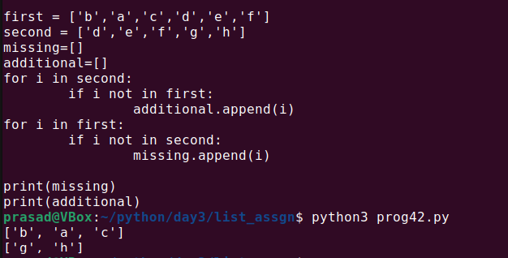

43. Write a Python program to split a list into different variables from center.

Ex.

l1=[12,23,34,45,56,67]

first=[12,23,34]

second=[45,56,67]

l2=[12,23,34,45,56,67,99]

first=[12,23,34]

second=[45,56,67,99]

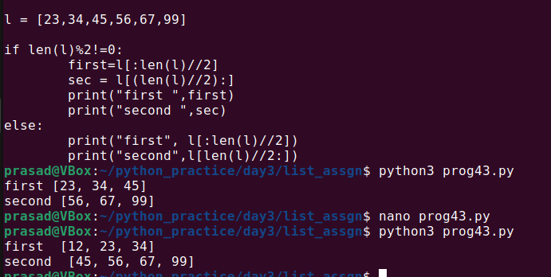

44. Write a Python program to generate groups of three consecutive numbers in a list.

l1=[1,2,3,4,5,6,7,8,9,10]

[1,2,3], [2,3,4], [3,4,5], [6,7,8], [7,8,9], [8,9,10]

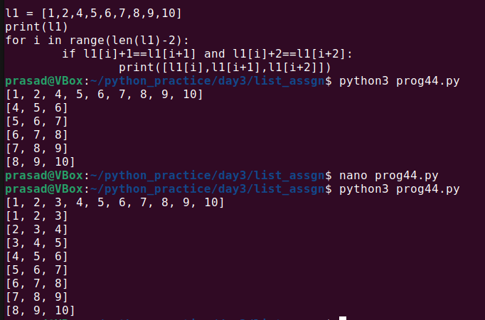

45. Write a Python program to take a list. Find all unique values. Then print all unique values in sorted order.

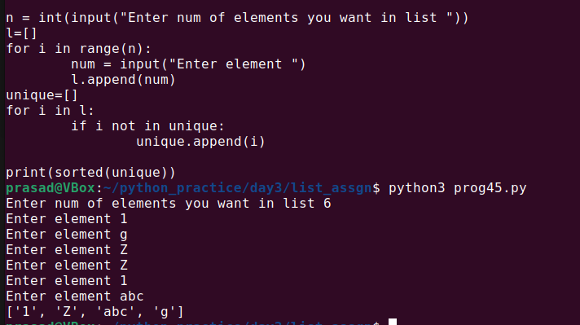

46. Write a Python program to select the odd elements from a list into new list.

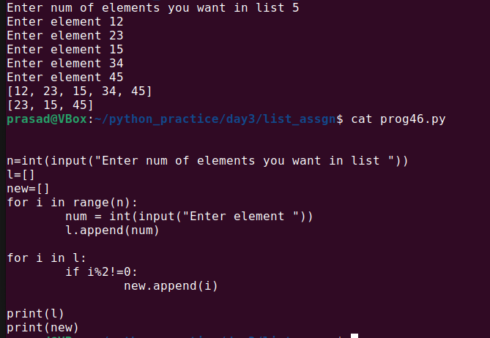

47. Write a Python program to insert an element before each element of a list.

Ex. l1=[1,2,3]

insert 10 before every element

o/p [10,1,10,2,10,3]

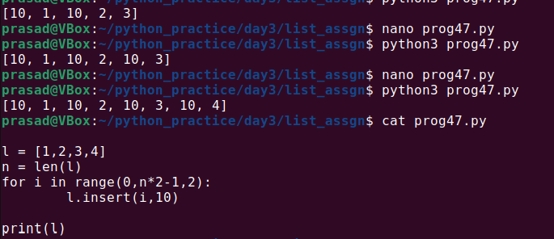

48. Write a Python program to print nested lists (each list on a new line) using the print() function.

l1=[[1,2,3],[4,5,6],[7,8]]

[1,2,3]

[4,5,6]

[7,8]

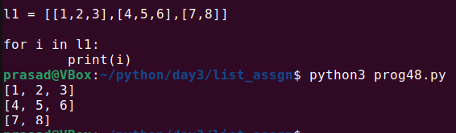

**49. Write a Python program to convert a list to a list of dictionaries. ( Hint: this is part of creating dictionaries)

Sample lists: ["Black", "Red", "Maroon", "Yellow"], ["#000000", "#FF0000", "#800000", "#FFFF00"]

Expected Output: [{'color_name': 'Black', 'color_code': '#000000'}, {'color_name': 'Red', 'color_code': '#FF0000'}, {'color_name': 'Maroon', 'color_code': '#800000'}, {'color_name': 'Yellow', 'color_code': '#FFFF00'}]

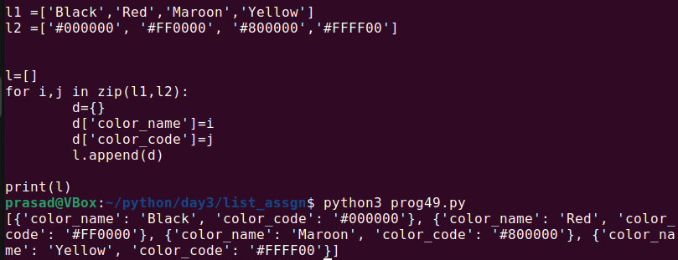

**50. Write a Python program to sort a list of nested dictionaries.

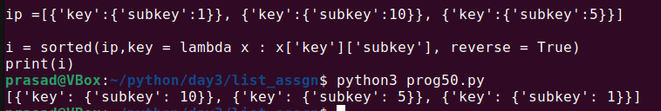

51. Write a Python program to split a list every Nth element.

Sample list:

l1=['a', 'b', 'c', 'd', 'e', 'f', 'g', 'h', 'i', 'j', 'k', 'l', 'm', 'n']

n=5

Expected Output: [['a', 'd', 'g', 'j', 'm'], ['b', 'e', 'h', 'k', 'n'], ['c', 'f', 'i', 'l']]

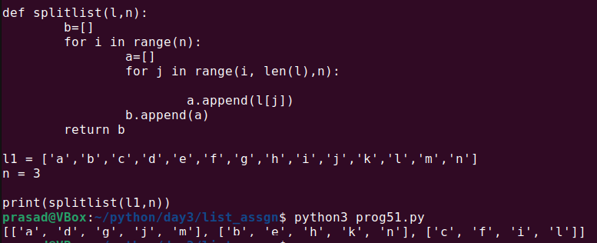

52. Write a Python program to compute the difference between two lists.

Sample data:

color1 = ["white", "red", "orange", "green", "blue"]

color2=["black", "yellow", "green", "blue"]

Expected Output:

Color1 - Color2: ['white', 'red', 'orange']

In color1, white, red and orange colors are there which are extra than color2

Color2 - Color1: ['black', 'yellow']

In color2, black and yellow colors are there which are extra than color2

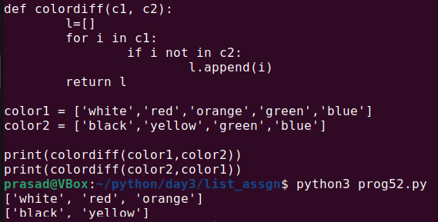

**53. Write a Python program to create a list with infinite elements.(this is part of generator function)

54. Write a Python program to concatenate elements of a given list to another list.

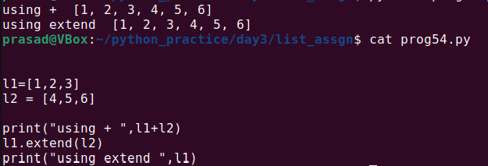

56. Write a Python program to convert a string to a list.

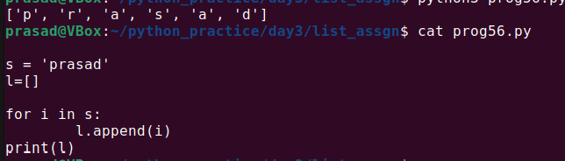

57. Write a Python program to count how many times a word comes in given list of words.

Ex

word = "cdac"

word_list=["cadc","cdac","iop","lkjh","cdac"]

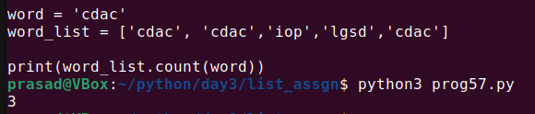

58. Write a Python program to replace the last element in a list with another list.

Sample data : [1, 3, 5, 7, 9, 10], [2, 4, 6, 8]

Expected Output: [1, 3, 5, 7, 9, 2, 4, 6, 8]

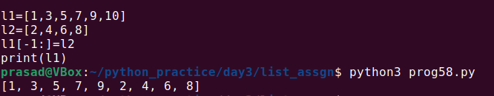

59. Write a Python program to check whether the n-th element exists in a given list. Dont give error if n is out of bounds, print out of bounds message.

Ex.

l1=[90,98,87,76,65]

n=1 o/p: exists ( explaination l1[1] exists)

n=10 o/p: out of bound index

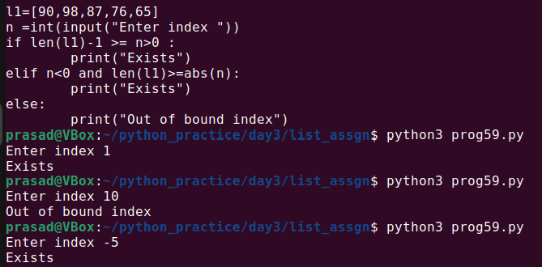

64. Write a Python program to iterate over two lists simultaneously.

ex.

l1=[2,4,7]

l2=[12,45,67]

output:

2 12

4 45

7 67

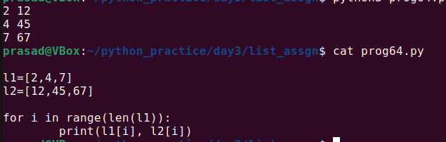

65. Write a Python program to move all zero digits to the end of a given list of numbers.

Original list:

[3, 4, 0, 0, 0, 6, 2, 0, 6, 7, 6, 0, 0, 0, 9, 10, 7, 4, 4, 5, 3, 0, 0, 2, 9, 7, 1]

Expected output:

Move all zero digits to end of the said list of numbers:

[3, 4, 6, 2, 6, 7, 6, 9, 10, 7, 4, 4, 5, 3, 2, 9, 7, 1, 0, 0, 0, 0, 0, 0, 0, 0, 0]

